**UNIT - 1**

**CLOUD COMPUTING**

Cloud computing refers to the on-demand delivery of computing services such as computing resources, storage, databases, networking resources etc. through internet on a pay-as-you-go basis.

It allows businesses to access data and services from anywhere, reducing the need for on-premises infrastructure.

This improves efficiency, cuts costs, and lets organizations focus on innovation and growth instead of managing IT systems.

**Essential Characteristics:-**

**1. On-Demand Self-Service:**

Consumers can independently provision computing resources such as server time, storage, and processing power as needed. This happens automatically without requiring any manual interaction with the service provider. It allows businesses to quickly adapt to changes in demand without delay, making operations more efficient.

**2. Remote Access:**

Cloud services are available over the internet and can be accessed from a wide variety of devices like smartphones, laptops, and tablets. These devices use standard communication protocols, ensuring easy access to cloud resources regardless of the platform. This allows users to connect to the cloud from anywhere with internet connectivity.

**3. Resource Pooling:**

Cloud providers pool physical and virtual resources to serve multiple users in a multi-tenant model. Resources such as storage, memory, and network bandwidth are dynamically assigned and reassigned based on consumer demand. Users don’t need to know the exact physical location of resources but may specify broader locations (e.g., datacenter region).

**4. Scalability:**

Cloud resources can be automatically scaled up or down quickly based on the user’s demand. This allows for seamless handling of sudden spikes or drops in workload, ensuring businesses only use what they need. To consumers, the resources appear nearly unlimited and are accessible in any quantity, whenever needed.

**5. Measured Service:**

Cloud services use metering systems to track and optimize resource usage (e.g., storage, processing, bandwidth). This ensures that both the provider and consumer have transparency into how much of a resource is being used. Usage is measured, controlled, and reported, allowing for a pay-as-you-go billing model where customers are charged only for what they consume.

**Types Of Cloud Computing Models (Service Models)**

**1. IaaS (Infrastructure as a Service)**

* It provides scalable and virtualized computing resources like servers, storage, and networking over the internet.
* In this service, users can have full control over the infrastructure, having customization and management access of virtual machines, storage and networking components.

**2. PaaS (Platform as a Service)**

* It provides a platform i.e. an environment for developers to build, deploy and manage applications without dealing with the underlying infrastructure.
* It offers tools and services such as development frameworks, databases and middleware, streamlining the application development lifecycle.

**3. SaaS (Software as a Service)**

* SaaS delivers software applications over the internet on a subscription basis. It eliminates the need for users to install, maintain, or update the software locally.
* With this service users can access the applications from any device with an internet connection, enabling flexibility and accessibility.

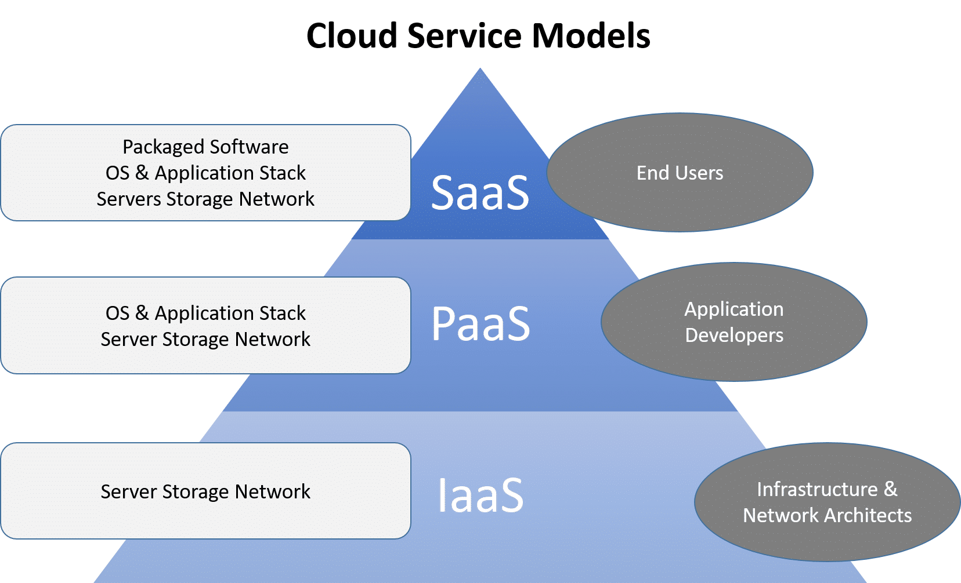

**Cloud Computing Deployment Models (Types of Cloud)**

**1. PUBLIC CLOUD**

The cloud infrastructure is provisioned for open use by the general public. It may be owned, managed, and operated by a business, academic, or government organization, or some combination of them. It exists on the premises of the cloud provider.

**Examples:**Amazon EC2, IBM, Azure, GCP

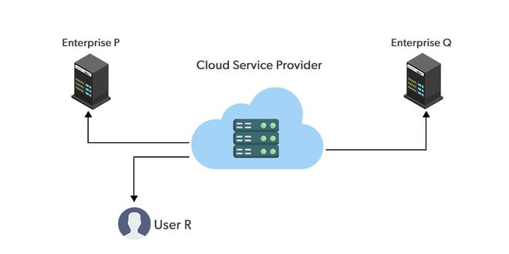

**Advantages of Public Cloud**

* Public cloud is easily able to scale up and down resources as per the demand of traffic and workload. It facilitates with performance optimization and cost efficiency.
* It works on pay-as-you-go cloud model and helps in resolving the investments needs in hardware and infrastructure reducing overall costs.

**Disadvantages of using Public Cloud**

* It is difficult to trust and maintain data to a third-party provider may raise concerns about control and ownership
* The shared infrastructure of public cloud resources increases the risk of data breaches and unauthorized access. It raises security and privacy concerns.
* Public cloud comes with limited transparency about the underlying infrastructure which may make it challenging to monitor and manage performance effectively.

**2. PRIVATE CLOUD**

The cloud infrastructure is provisioned for exclusive use by a single organization comprising multiple consumers (e.g., business units). It may be owned, managed, and operated by the organization, a third party, or some combination of them, and it may exist on or off premises.

**Examples:**VMware vCloud Suite, OpenStack, Cisco Secure Cloud, Dell Cloud Solutions, HP Helion Eucalyptus

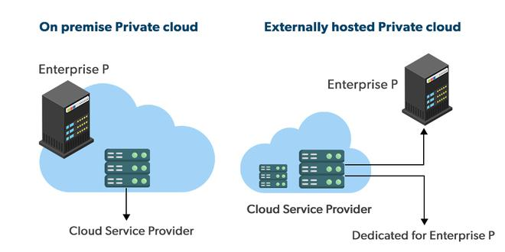

**Advantages Of Private Cloud**

* **Customer information protection:** In the private cloud security concerns are less since customer data and other sensitive information do not flow out of private infrastructure.
* **Infrastructure** **ensuring** **SLAs:** Private cloud provides specific operations such as appropriate clustering, data replication, system monitoring, and maintenance, disaster recovery, and other uptime services.
* **Compliance with standard procedures and operations:** Specific procedures have to be put in place when deploying and executing applications according to third-party compliance standards. This is not possible in the case of the public cloud.

**Disadvantages Of Private Cloud**

* **The restricted area of operations:** Private cloud is accessible within a particular area. So the area of accessibility is restricted.
* **Expertise required:** In the private cloud security concerns are less since customer data and other sensitive information do not flow out of private infrastructure. Hence skilled people are required to manage & operate private cloud services.

**3. HYBRID CLOUD**

The cloud infrastructure is a composition of two or more distinct cloud infrastructures (private, community, or public) that remain unique entities, but are bound together by standardized or proprietary technology that enables data and application portability (e.g., cloud bursting for load balancing between clouds).

**Examples:** AWS Outposts, Azure Stack, Google Anthos, IBM Cloud Satellite, Oracle Cloud at Customer

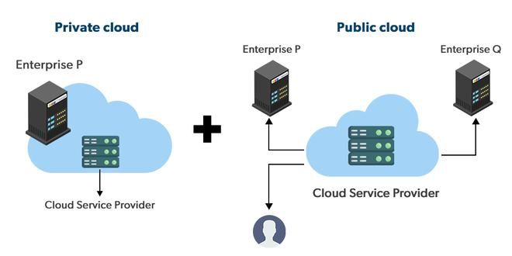

**Advantages of using Hybrid cloud**

* Hybrid cloud is available at a cheap cost than other clouds because it is formed by a distributed system.
* It works comes up with working fast with lower cost and facilitates in reducing the latency of the data transfer process.
* Most important thing is security. A hybrid cloud is totally safe and secure because it works on the **distributed system network**.

**Disadvantages of Using Hybrid Cloud**

* It’s possible that businesses lack the internal knowledge necessary to create such a hybrid environment. Managing security may also be more challenging. Different access levels and security considerations may apply in each environment.
* Managing a hybrid cloud may be more difficult. With all of the alternatives and choices available today, not to mention the new PaaS components and technologies that will be released every day going forward, public cloud and migration to public cloud are already complicated enough.

**4. COMMUNITY CLOUD**

The cloud infrastructure is provisioned for exclusive use by a specific community of consumers from organizations that have common interest (e.g., mission, security requirements, policy, and compliance considerations). It may be owned, managed, and operated by one or more of the organizations in the community, a third party, or some combination of them, and it may exist on or off premises.

**Examples:**CloudSigma, Nextcloud, Synology C2, OwnCloud, Stratoscale

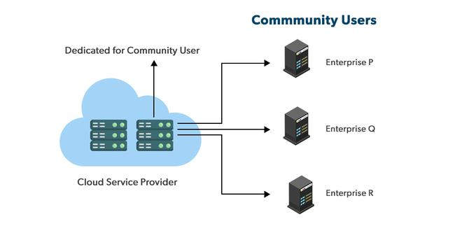

**Advantages of Using Community Cloud**

* Because the entire cloud is shared by numerous enterprises or a community, community clouds are cost-effective.
* Because it works with every user, the community cloud is adaptable and scalable. Users can alter the documents according to their needs and requirements.
* Thanks to community clouds, we may share cloud resources, infrastructure, and other capabilities between different enterprises.

**Disadvantages of using Community Cloud**

* Not all businesses should choose community cloud.
* Gradual adoption of data
* It’s challenging for corporations to share duties.

**5. MULTICLOUD**

Multicloud is the use of multiple cloud computing services from different providers, which allows organizations to use the best-suited services for their specific needs and avoid vendor lock-in. This allows organizations to take advantage of the different features and capabilities offered by different cloud providers.

**Examples:**Cloud Foundry, Kubernetes, Apache Mesos, Red Hat OpenShift, Docker Swarm.

**Advantages of using Multi-Cloud**

* **Flexibility:** Using multiple cloud providers allows organizations to choose the best-suited services for their specific needs, and avoid vendor lock-in.
* **Cost-effectiveness:** Organizations can take advantage of the cost savings and pricing benefits offered by different cloud providers for different services.
* **Improved performance**: By distributing workloads across multiple cloud providers, organizations can improve the performance and availability of their applications and services.
* **Increased security:** Organizations can increase the security of their data and applications by spreading them across multiple cloud providers and implementing different security strategies for each.

**Disadvantages of using Multi-Cloud**

* **Complexity**: Managing multiple cloud providers and services can be complex and require specialized knowledge and expertise.
* **Increased costs:** The cost of managing multiple cloud providers and services can be higher than using a single provider.
* **Compatibility issues**: Different cloud providers may use different technologies and standards, which can cause compatibility issues and require additional resources to resolve.
* **Limited interoperability:** Different cloud providers may not be able to interoperate seamlessly, which can limit the ability to move data and applications between them.

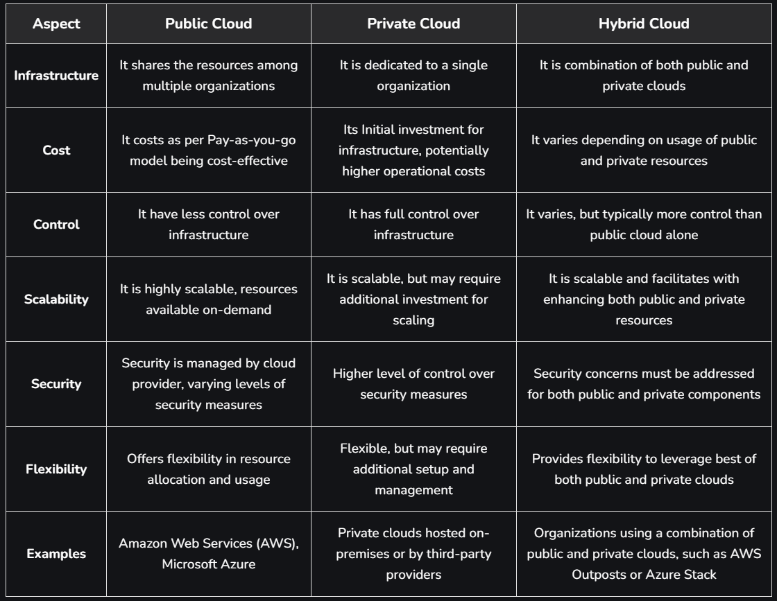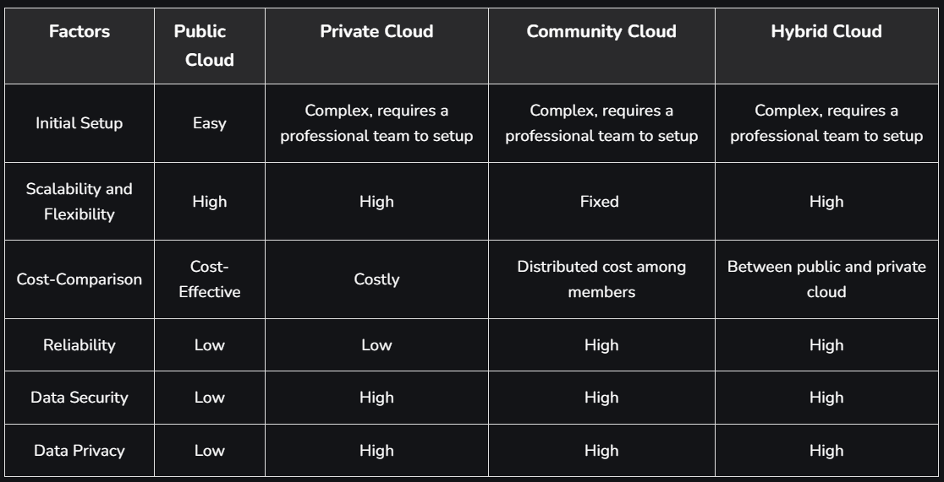**DIFFERENCE BETWEEN PUBLIC CLOUD, PRIVATE CLOUD AND HYBRID CLOUD**

**LAYERS OF CLOUD COMPUTING**

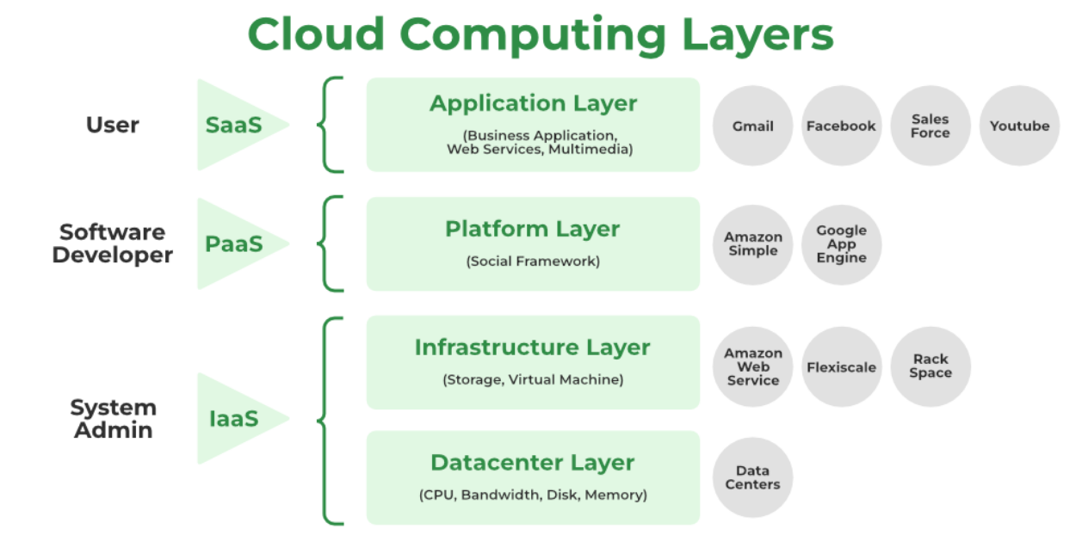

**APPLICATION LAYER**

1. The application layer, which is at the top of the stack, is where the actual cloud apps are located. Cloud applications, as opposed to traditional applications, can take advantage of the automatic-scaling functionality to gain greater performance, availability, and lower operational costs.
2. This layer consists of different Cloud Services which are used by cloud users. Users can access these applications according to their needs. Applications are divided into Execution layers and Application layers.
3. In order for an application to transfer data, the application layer determines whether communication partners are available. Whether enough cloud resources are accessible for the required communication is decided at the application layer. Applications must cooperate in order to communicate, and an application layer is in charge of this.
4. The application layer, in particular, is responsible for processing IP traffic handling protocols like Telnet and FTP. Other examples of application layer systems include web browsers, SNMP protocols, HTTP protocols, or HTTPS, which is HTTP’s successor protocol.

**PLATFORM LAYER**

1. The operating system and application software make up this layer.
2. Users should be able to rely on the platform to provide them with Scalability, Dependability, and Security Protection which gives users a space to create their apps, test operational processes, and keep track of execution outcomes and performance. SaaS application implementation’s application layer foundation.
3. The objective of this layer is to deploy applications directly on virtual machines.
4. Operating systems and application frameworks make up the platform layer, which is built on top of the infrastructure layer. The platform layer’s goal is to lessen the difficulty of deploying programmers directly into VM containers.
5. By way of illustration, Google App Engine functions at the platform layer to provide API support for implementing storage, databases, and business logic of ordinary web apps.

**INFRASTRUCTURE LAYER**

1. It is a layer of virtualization where physical resources are divided into a collection of virtual resources using virtualization technologies like Xen, KVM, and VMware.
2. This layer serves as the Central Hub of the Cloud Environment, where resources are constantly added utilizing a variety of virtualization techniques.
3. A base upon which to create the platform layer. constructed using the virtualized network, storage, and computing resources. Give users the flexibility they want.
4. Automated resource provisioning is made possible by virtualization, which also improves infrastructure management.
5. The infrastructure layer sometimes referred to as the virtualization layer, partitions the physical resources using virtualization technologies like Xen, KVM, Hyper-V, and VMware to create a pool of compute and storage resources.
6. The infrastructure layer is crucial to cloud computing since virtualization technologies are the only ones that can provide many vital capabilities, like dynamic resource assignment.

**DATACENTER LAYER**

1. In a cloud environment, this layer is responsible for Managing Physical Resources such as servers, switches, routers, power supplies, and cooling systems.
2. Providing end users with services requires all resources to be available and managed in data centers.
3. Physical servers connect through high-speed devices such as routers and switches to the data center.
4. In software application designs, the division of business logic from the persistent data it manipulates is well-established. This is due to the fact that the same data cannot be incorporated into a single application because it can be used in numerous ways to support numerous use cases. The requirement for this data to become a service has arisen with the introduction of microservices.
5. A single database used by many microservices creates a very close coupling. As a result, it is hard to deploy new or emerging services separately if such services need database modifications that may have an impact on other services. A data layer containing many databases, each serving a single microservice or perhaps a few closely related microservices, is needed to break complex service interdependencies.

**CLOUD COMPUTING ARCHITECTURE**

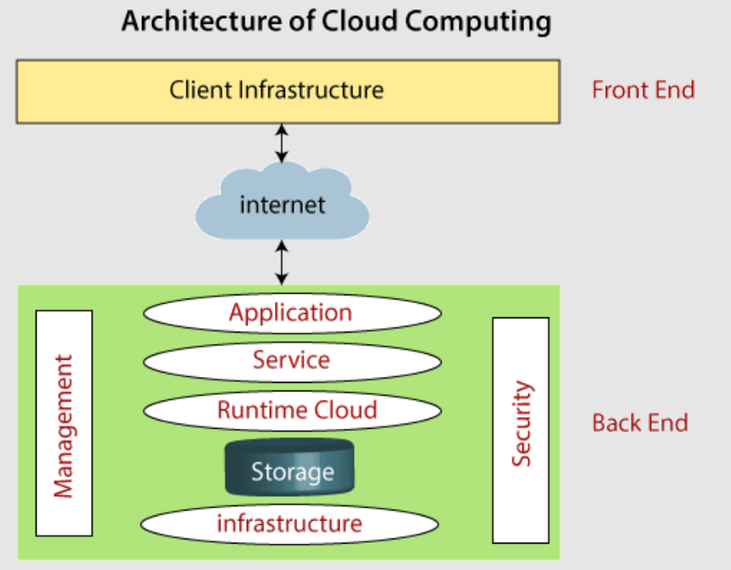

Architecture of cloud computing is the combination of both **SOA** (Service Oriented Architecture) and **EDA** (Event Driven Architecture). Client infrastructure, application, service, runtime cloud, storage, infrastructure, management and security all these are the components of cloud computing architecture.

The cloud architecture is divided into **two** parts :-

1. **FRONTEND**

Frontend of the cloud architecture refers to the **client side** of cloud computing system. Means it contains all the user interfaces and applications which are used by the client to access the cloud computing services.

For example :- use of a web browser to access the cloud platform.

1. **BACKEND**

Backend refers to the **cloud** **itself** which is used by the service provider. It contains and manages the resources and provides security mechanisms. It also includes huge storage, virtual applications, virtual machines, traffic control mechanisms, deployment models, etc.

**Components of Cloud Computing Architecture**

* **Client Infrastructure:** Client Infrastructure is a part of the frontend component. It contains the applications and user interfaces which are required to access the cloud platform. In other words, it provides a **GUI** (Graphical User Interface) to interact with the cloud.
* **Application:** Application is a part of backend component that refers to a software or platform through which the client accesses. Means it provides the service in backend as per the client requirement.
* **Service:** Service in backend refers to the major three types of cloud based services like SaaS, PaaS and IaaS. Also manages which type of service the user accesses.
* **Runtime Cloud:** Runtime cloud in backend provides the execution and Runtime platform/environment to the **Virtual machines**.
* **Storage:**Storage in backend provides flexible and scalable storage service and management of stored data.
* **Infrastructure:**Cloud Infrastructure in backend refers to the hardware and software components of cloud like servers, storage, network devices, virtualization software etc.
* **Management:**Management in backend refers to management of backend components like application, service, runtime cloud, infrastructure, storage and other security mechanisms etc.
* **Security:**Security in backend refers to implementation of different security mechanisms in the backend for secure cloud resources, systems, files and infrastructure to end-users.
* **Internet:**Internet connection acts as the medium or a bridge between frontend and backend and establishes the interaction and communication between frontend and backend.
* **Database:** Database in backend refers to provide database for storing structured data, such as SQL and NOSQL databases. Example of Databases services include Amazon RDS, Microsoft Azure SQL database and Google CLoud SQL.
* **Networking:**It provides networking infrastructure for application in the cloud, such as load balancing, DNS and virtual private networks.
* **Analytics:**It provides analytics capabilities for data in the cloud, such as warehousing, business intelligence and machine learning.

**VIRTUALIZATION**

**Virtualization**is used to create a **virtual version** of an underlying service. With the help of Virtualization, multiple operating systems and applications can run on the same machine and use the same hardware at the same time, increasing the utilization and flexibility of hardware. It is one of the main **cost-effective**, **hardware-reducing**, **and energy-saving** techniques used by cloud providers.

Virtualization allows sharing of a single physical instance of a resource or an application among multiple customers and organizations at the same time. It does this by assigning a logical name to physical storage and providing a pointer to that physical resource on demand. Moreover, virtualization technologies provide a virtual environment not only for executing applications but also for storage, memory, and networking.

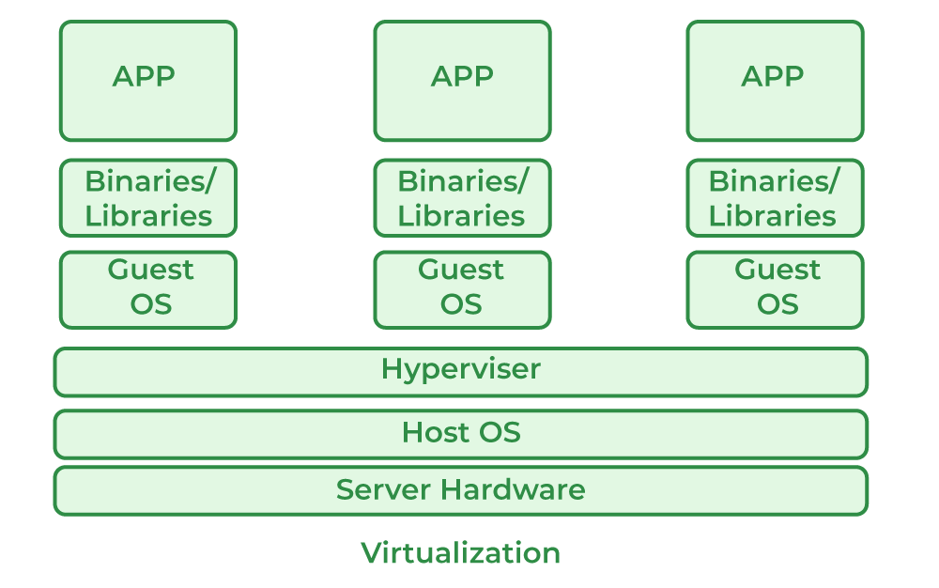

* **Host Machine**: The machine on which the virtual machine is going to be built is known as Host Machine.
* **Guest Machine**: The virtual machine is referred to as a Guest Machine.

**Benefits of Virtualization**

* More flexible and efficient allocation of resources.
* Enhance development productivity.
* It lowers the cost of IT infrastructure.
* Remote access and rapid scalability.
* High availability and disaster recovery.
* Pay per use of the IT infrastructure on demand.
* Enables running multiple operating systems.

**Characteristics of Virtualization**

* **Increased Security:** The ability to control the execution of a guest program in a completely transparent manner opens new possibilities for delivering a secure, controlled execution environment. All the operations of the guest programs are generally performed against the virtual machine, which then translates and applies them to the host programs.
* **Managed Execution:** In particular, sharing, aggregation, emulation, and isolation are the most relevant features.
* **Sharing:** Virtualization allows the creation of a separate computing environment within the same host.
* **Aggregation:** It is possible to share physical resources among several guests, but virtualization also allows aggregation, which is the opposite process.

1. **Network Virtualization**: Network virtualization allows multiple virtual networks to run on a single physical network. Each virtual network operates independently with its own control and data plan.

* Separation: Virtual networks are isolated from each other, meaning different parties can manage them securely.
* Components: Includes virtual routers, switches, firewalls, load balancers, and VPNs.
* Flexibility: Network resources like bandwidth and connectivity can be provisioned in minutes.
* Use Case: Ideal for creating private networks (e.g., VPNs) and securely managing network traffic for different users on the same physical network.

Benefits:

* Efficient Use of Resources: Multiple networks share the same infrastructure, reducing the need for separate hardware.
* Rapid Deployment: Virtual networks can be created and configured quickly without waiting for physical changes.
* Scalability: Virtual networks can grow and shrink easily based on need.

2. **Storage Virtualization**: Storage virtualization is a process where physical storage from different servers are combined into one virtual storage system. The individual servers don’t need to know where data is stored; they access it as if it’s all in one place.

* Unified Storage: It combines multiple storage devices into one virtual storage pool.
* Easy Management: Administrators can manage and use all storage resources as a single unit, regardless of where data is physically stored.
* Dynamic: The storage system continues to operate smoothly even when the underlying hardware changes or breaks down.

Benefits:

* Improved Performance: Data can be accessed more quickly because it’s distributed across multiple devices.
* Increased Flexibility: Makes it easier to add or remove storage without downtime.
* Cost-Effective: Multiple storage systems can be managed as one, reducing complexity and cost.

3. **Compute Virtualization**: Compute virtualization allows multiple virtual machines (VMs) to run on a single physical server. Each VM acts like an independent computer with its own operating system and applications.

* Hypervisor: Software that manages VMs and allocates hardware resources like CPU, memory, and storage.
* Isolation: Each VM is isolated from others, so issues in one don’t affect the others.
* Resource Pooling: Physical resources are pooled and shared among all the VMs.

Benefits:

* Efficient Resource Use: Allows multiple operating systems and applications to run on a single machine.
* Cost Savings: Reduces the need for multiple physical servers.
* Scalability: VMs can be added or removed based on workload needs.
* Fault Tolerance: If one VM fails, others continue running smoothly.

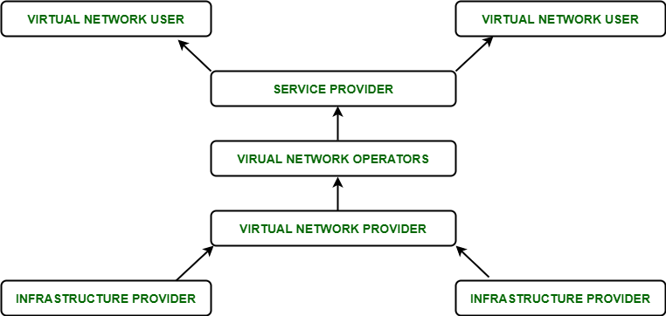

**Hypervisor**

A hypervisor is **a form of virtualization software** used in Cloud hosting **to create and manage virtual machines on a host system**. The hypervisor is a **hardware virtualization technique** that allows multiple guest operating systems (OS) to run on a single host system at the same time. A hypervisor is sometimes also called a **virtual machine manager (VMM)**.

**Types of Hypervisor –**

**TYPE-1 Hypervisor:**The hypervisor runs directly on the underlying host system. It is also known as a “**Native Hypervisor**” or “**Bare metal hypervisor**”. It does not require any base server operating system. It has direct access to hardware resources. Examples of Type 1 hypervisors include **VMware ESXi, Citrix XenServer, and Microsoft Hyper-V hypervisor**.

***Pros & Cons of Type-1 Hypervisor:***

**Pros:** Such kinds of hypervisors are very efficient because they have direct access to the physical hardware resources (like Cpu, Memory, Network, and Physical storage). This causes the empowerment of the security because there is no third party resource so that attacker couldn’t compromise with anything.

**Cons:** One problem with Type-1 hypervisors is that they usually need a dedicated separate machine to perform their operation and to instruct different VMs and control the host hardware resources.

**TYPE-2 Hypervisor:**A Host operating system runs on the underlying host system. It is also known as ‘**Hosted Hypervisor**”. Such kind of hypervisors doesn’t run directly over the underlying hardware rather they **run as an application** in a Host system (physical machine). Basically, the software is installed on an operating system. Hypervisor asks the operating system to make hardware calls. An example of a Type 2 hypervisor includes **VMware Player or Parallels Desktop**. Hosted hypervisors are often found on endpoints like PCs. The type-2 hypervisor is very useful for engineers, and security analysts (for checking malware, or malicious source code and newly developed applications).

***Pros & Cons of Type-2 Hypervisor:***

**Pros:** Such kind of hypervisors allows quick and easy access to a guest Operating System alongside the running host machine. These hypervisors usually come with additional useful features for guest machines. Such tools enhance the coordination between the host machine and the guest machine.

**Cons:** Here there is no direct access to the physical hardware resources so the efficiency of these hypervisors lags in performance as compared to the type-1 hypervisors, and potential security risks are also there an attacker can compromise the security weakness if there is access to the host operating system so he can also access the guest operating system.

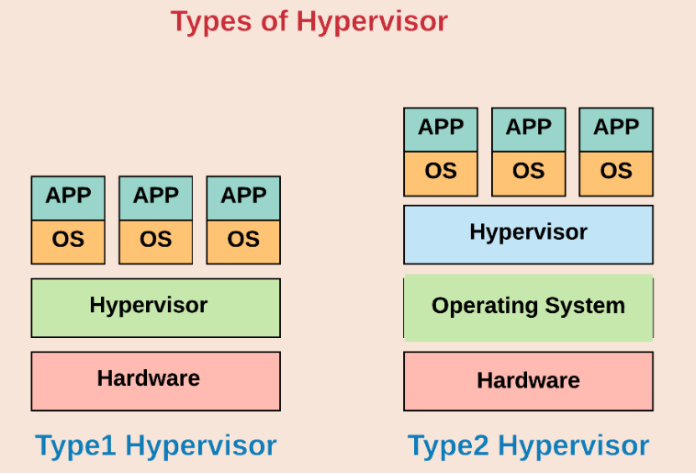

**CLOUD REFERENCE MODEL**

